# Culture App

EXECUTIVE SUMMARY

# Overview

An app used for local small businesses to help grow product distribution.

# The Problem

* Small ethnic businesses in the community have a problem with Bigger competitive businesses getting their products main streamed or available.
* The target area is small local business that can offer the same product sold at other stores like Walmart, but this app aims to help them get more attention to their products as well as the more a dollar is spent within the community the better the tax paying community benefits from it locally.
* Even though you can get products to be sold through competition like amazon or eBay, they are often overshadowed by product’s being the same or similar offered at a lower price rate.

# The Solution

* This app is intended to help small businesses break into a more modern-day age where online shopping is at an all-time high and using apps from your favorite store to shop.
* The solution sounds to be simple but is more complex as people tend to stick with what they know or trust.
* Starting an app in today’s market has statistically been proven to be tough but we feel like if we can make a simple app that can provide online shopping without the need to go through competition to do so, we could break the norm and allow more small local businesses.

# Keys to Success

* The plan is to create an app for business to connect with clients and help them either buy the product and have it distributed to them or to go into the store itself.
* Some useful resources to help make this happen would be: fundraising for a team to create the app, promotion to help bring awareness for the app, and a local support for small businesses to help them keep growing.
* A possible time line would be 2-3 years for the app to get started and running properly then another 2 years for local support and others to provide consistency using the app.

# What Makes My System Special and Unique?

What advantages I have over others would be an app used to help the small businesses with little interaction with a third-party system having to get involved. By third party I mean businesses such as Amazon or eBay where you have a process of getting your product shipped to your clients with additional cost with stocking or paying for the usage of the app. We want to create a space were the businesses are more in control of distributing their inventory provide shipping labels for them to package and ship off. We still would offer the same distribution if small business does not want to deal with logistics but at a more competitive rate then the competition. Below is my use case description of my app and the diagram of how its function between the intended user and business owner:

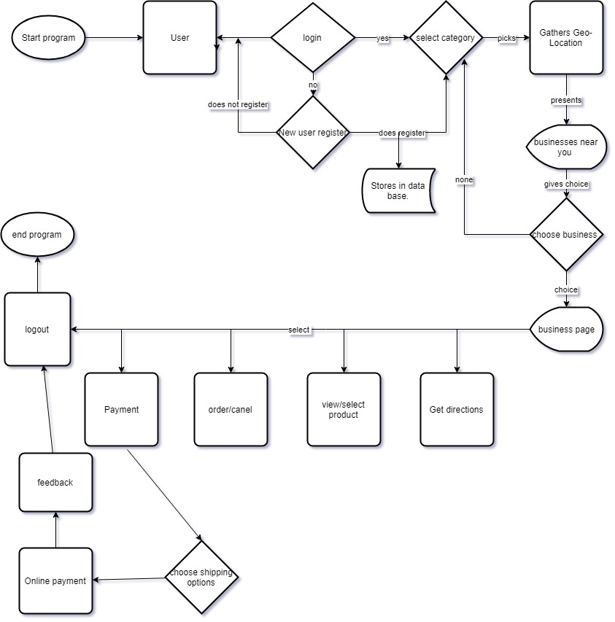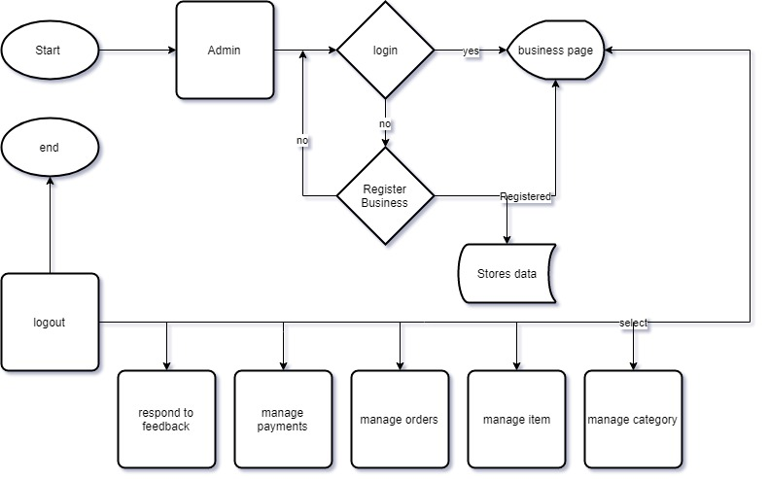

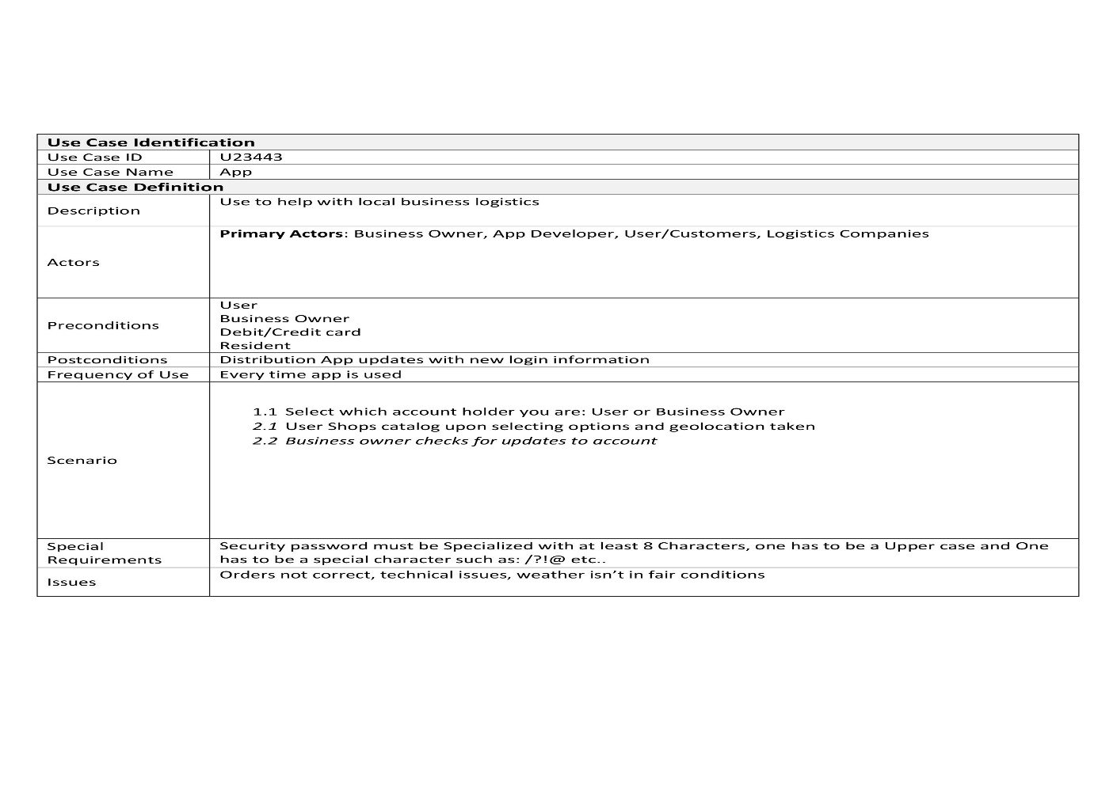

# Ideal Market

The targeted market for this app is small businesses struggling against larger corporations to transcend into a modern-day shopping, Local communities who could grow locally from the revenue increasing at these small businesses, and clients looking for unique and original products. I plan on starting out in the nearest local city with a good sample of business possible to get an ideal of how the system would work and any problems or implications I would need to make before testing it in a more global market. Below is the class diagram of my app:

# End-User Sequence Chart

These are my sequence diagrams for a User and The Business owner that show what data is captured by the app:

# Who can benefit from this app Profitability wise?

The main profiters are the ones of the community, city, and small business. But with all the data we received we can use that to make a profitable cause for the app since we are not really charging for the use of the app unless the business owner wants us to distribute its resources for them. By data capturing what the users tend to shop, as well as, what the business owners sell, we can make a profit by outsourcing this data. Outsourcing the date has several benefits as we can see a savings in labor over the long term as it frees up time for our employees to put labor elsewhere. And even though it would cost us to up keep the technology of an automated data capturing systems, we can then dive into the data and find what we can sell to other sources that can use this data to better give you what you want. For example, you can sell to advertising from the products you’ve recently purchased, logistics companies for a better demographic of who is using their service in which areas the most, or other big companies so they can use this data for future inventory to allow them a chance at giving you the best products.

# Summary

In conclusion, this app can be used in a good way for communities to grow. By spending your dollar locally, you increase the profit margins within the community, giving more opportunities to expand businesses, increase the employment rate, provide better education through taxes, bring in more people that want to live in this community, and overall just improving the infrastructure of each city big or small. This app is intended to bring people together by giving more awareness of consumer goods and services that are done locally instead of allocating resources somewhere else. There is a saying “the grass is not always greener on the other side of the fence”, and you should take this meaning as it is always going to be greener where you nurture the roots you’re living on. If you truly believe in your local community and the people you should make better choices to help improve were you are for future generations to come.